**Path=”/”**

How To set Up Project:

1. Download the frontend and Backend Source
2. Open Frontend code in Visual Studio vite and run command npm run dev
3. Open Backend code in intellij and Run the project
4. Now open database and Run the bellow Commands
5. Admin name: User
6. User name: Admin

* use busReservation;
* insert into roles(name) values ("ROLE_ADMIN");
* insert into roles(name) values ("ROLE_USER");
* insert into user_roles values (1,1);
* insert into user_roles values (2,2);
* insert into user_roles values (2,1);
* In Util -> PasswordEncoder-> Generate the Password and Paste in Password Field
* insert into user_security(email,name,password,username) values("user@gmail.com","user","$2a$10$KzDoHvizke88n7AUxTTS2e0hmPVyjpQ8pEWMMZ0ZQC.WXVjrxpOGq","user");
* insert into user_security(email,name,password,username) values("admin@gmail.com","admin","$2a$10$qfDXoHKJZWznoB0AMFmJB.d4.G.N2WgJUbom8TTUaqKtE1O6Ea/hy","admin");

**Home Page of the Application from which we can navigate to rest Components**

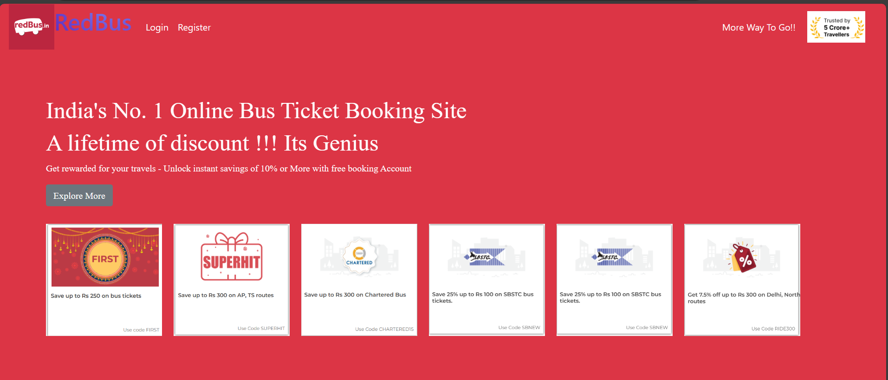

**Login:**

As Admin:

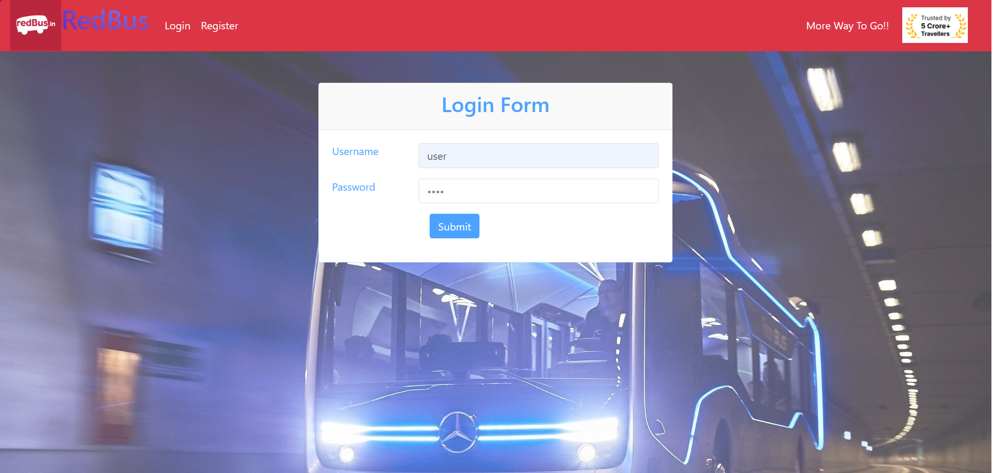

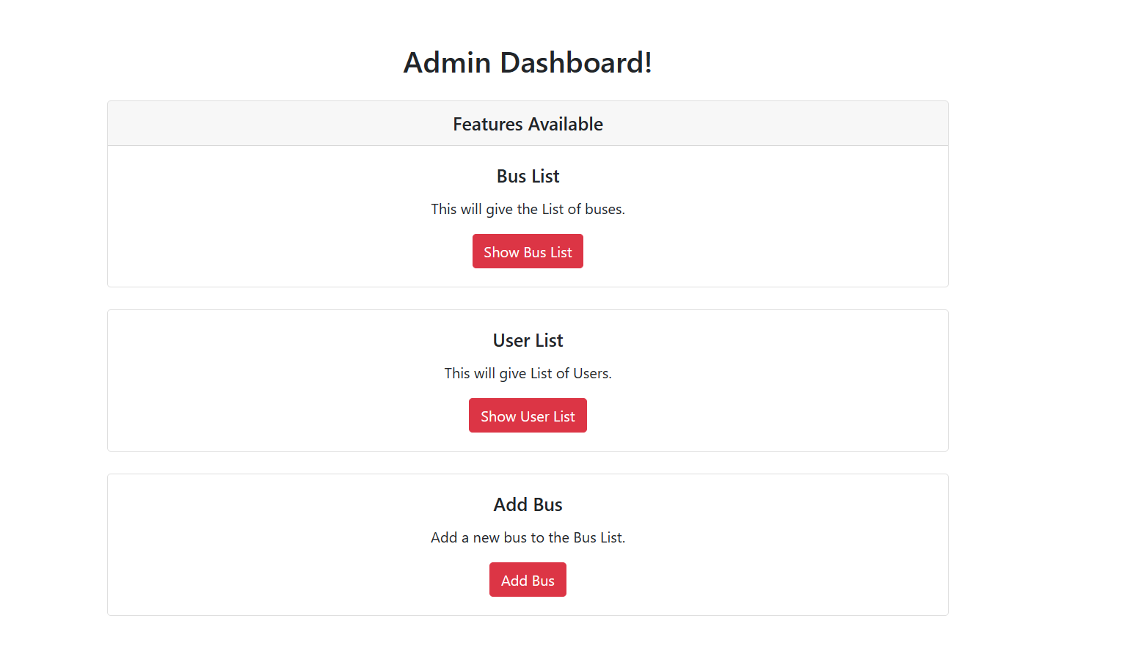

AddBus:

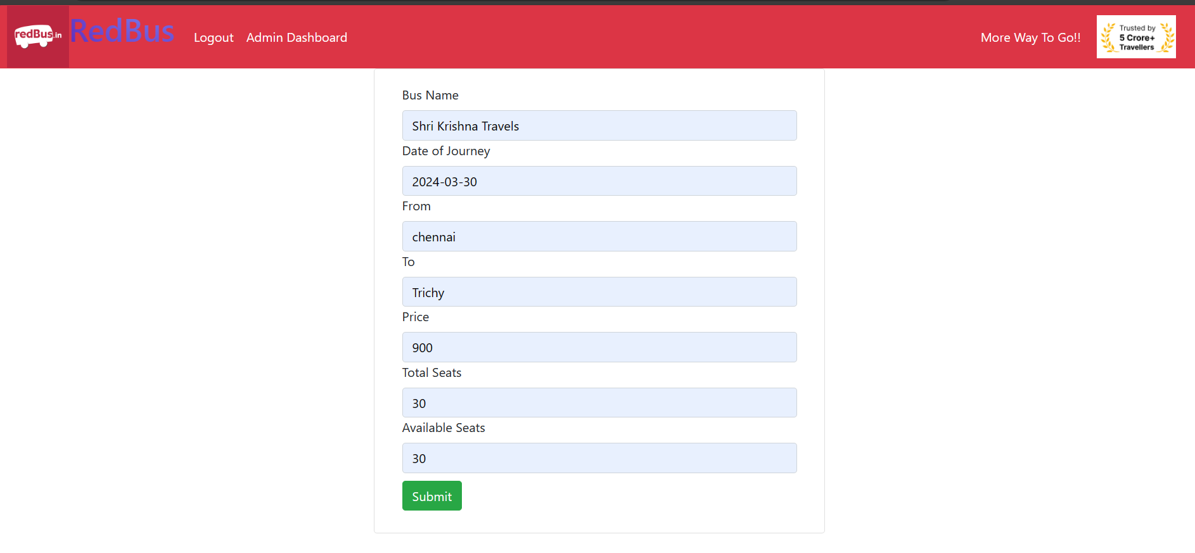

Show Bus List:

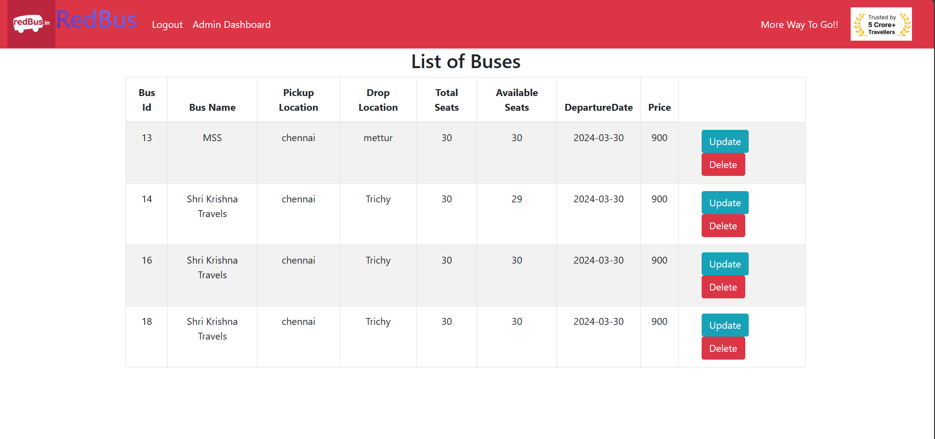

Update Bus Details

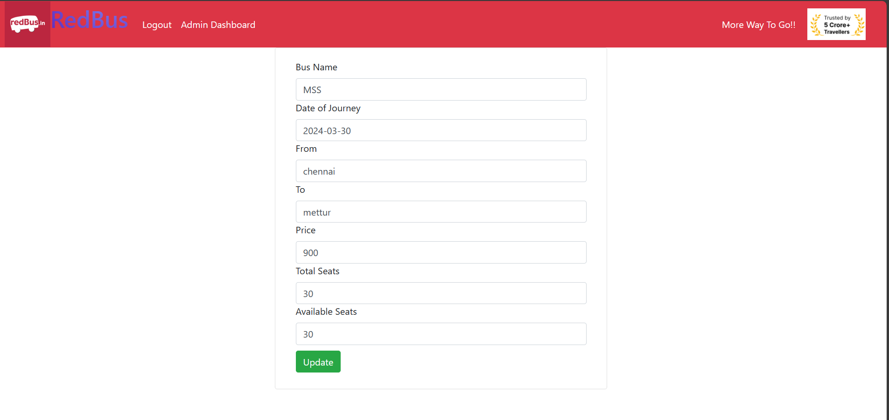

Changing the Price Field:

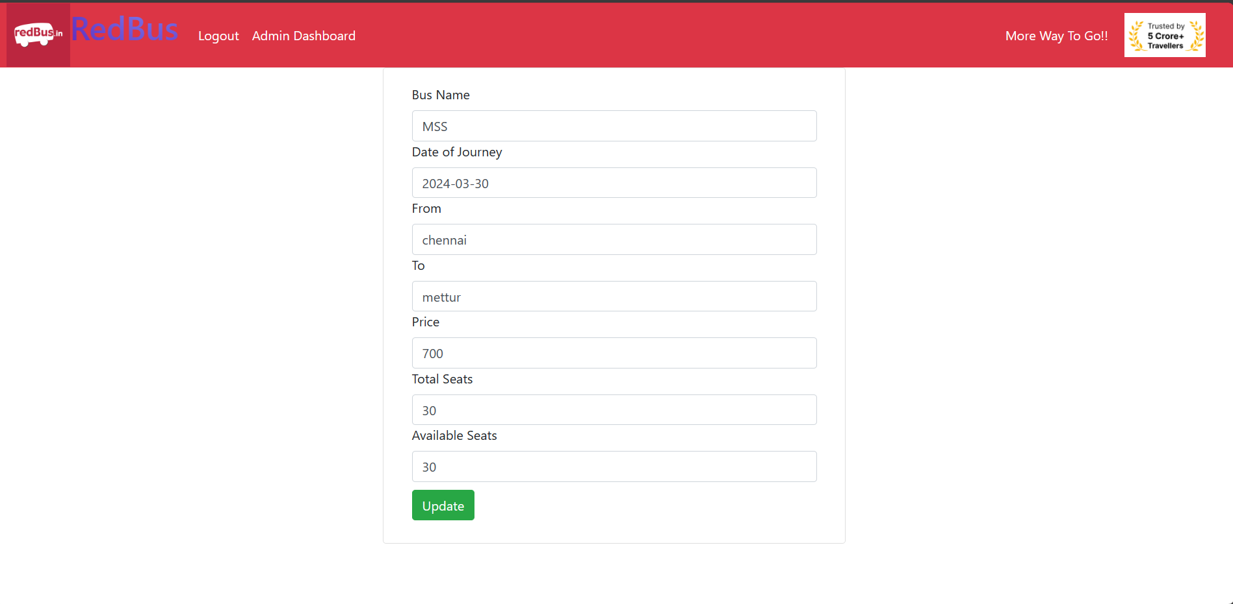

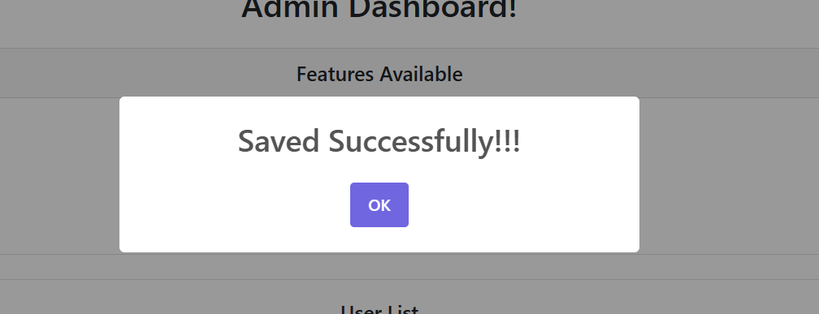

Price of MSS bus changed to 700

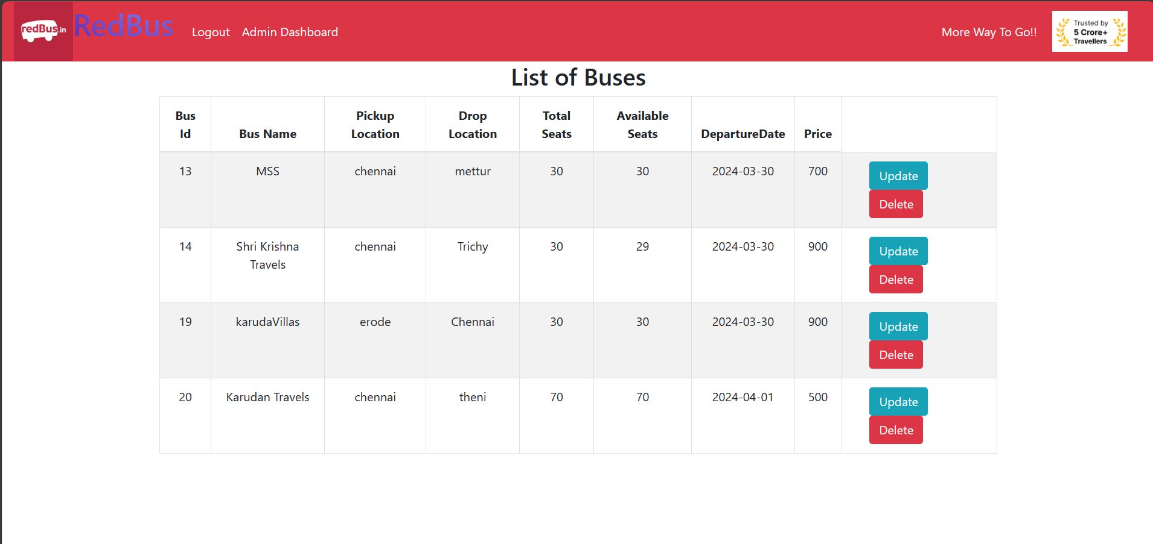

Deleting the Bus KarudaVillas:

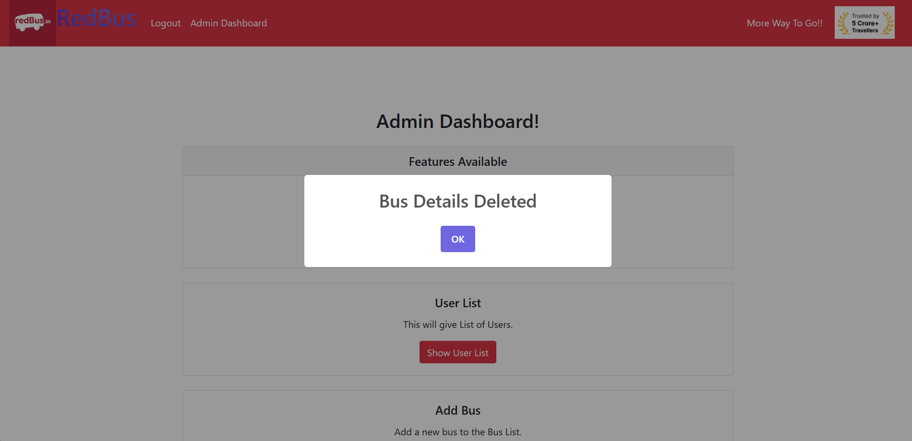

Bus got deleted:

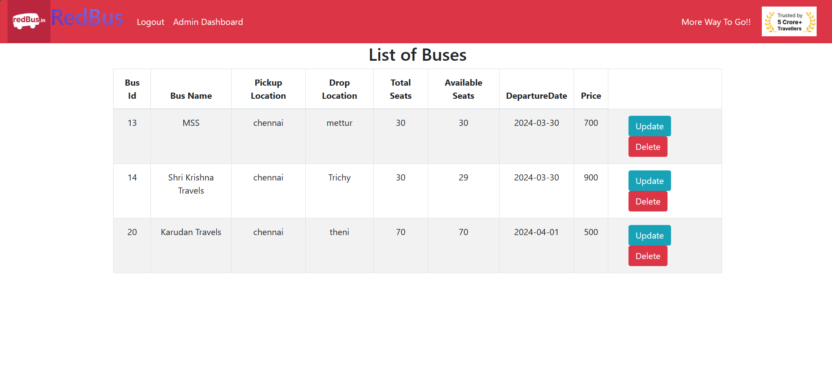

Show User List:

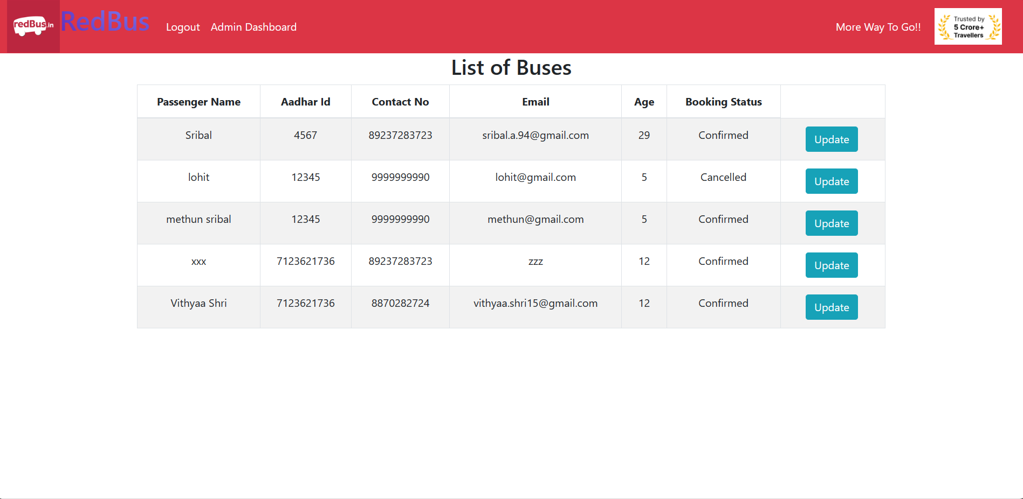

Update User List xxx:

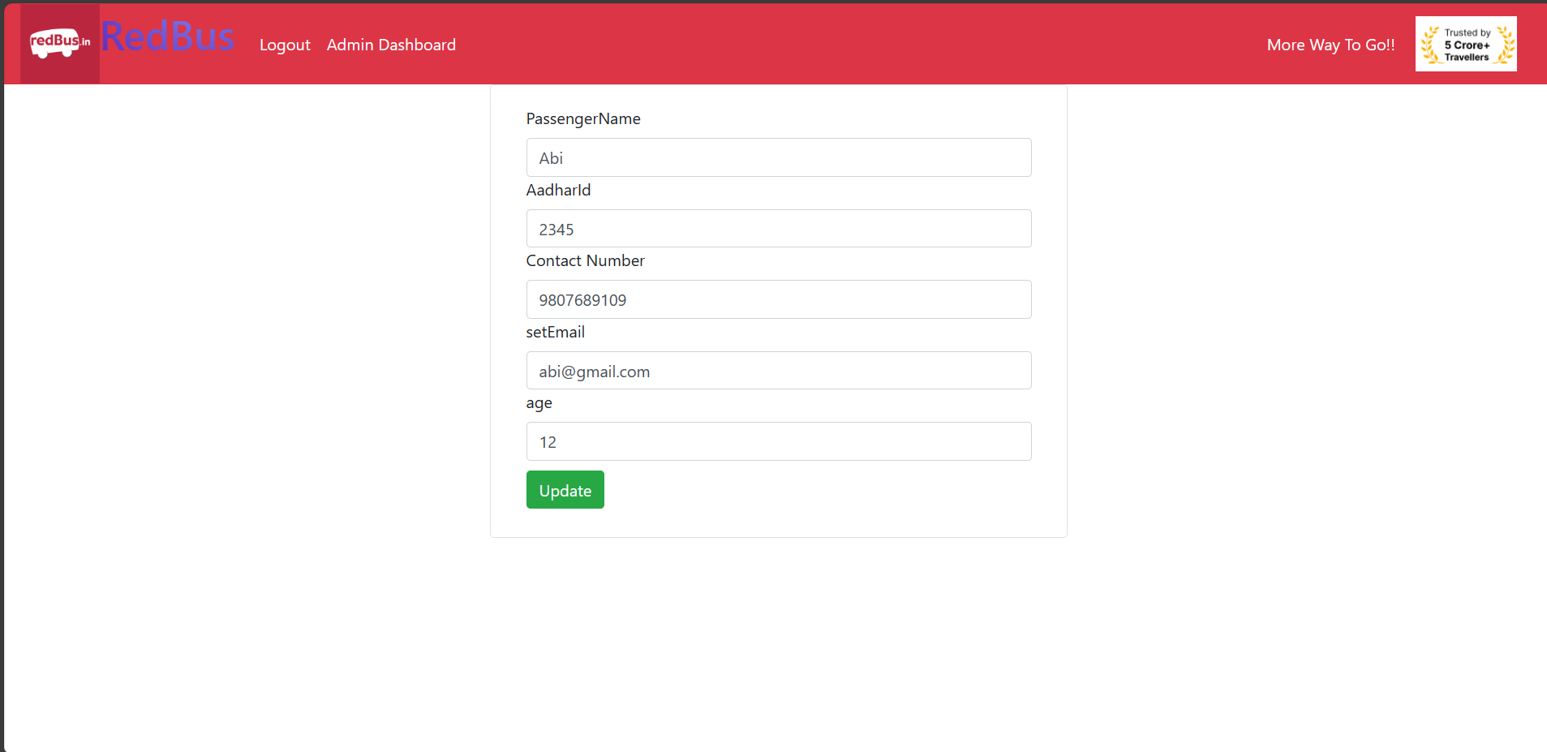

Xxx User got Updated:

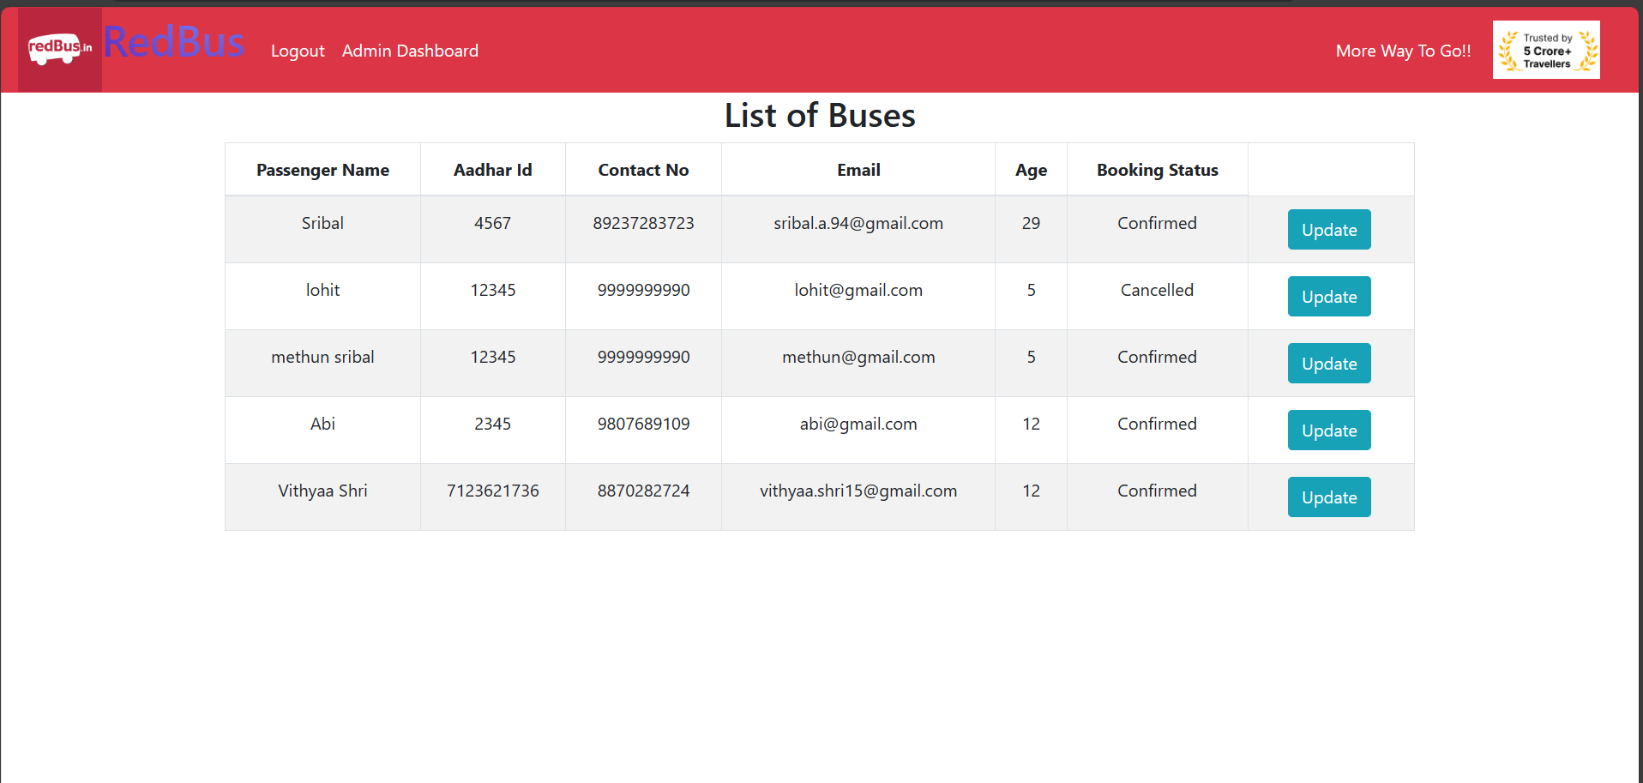

Register as User:

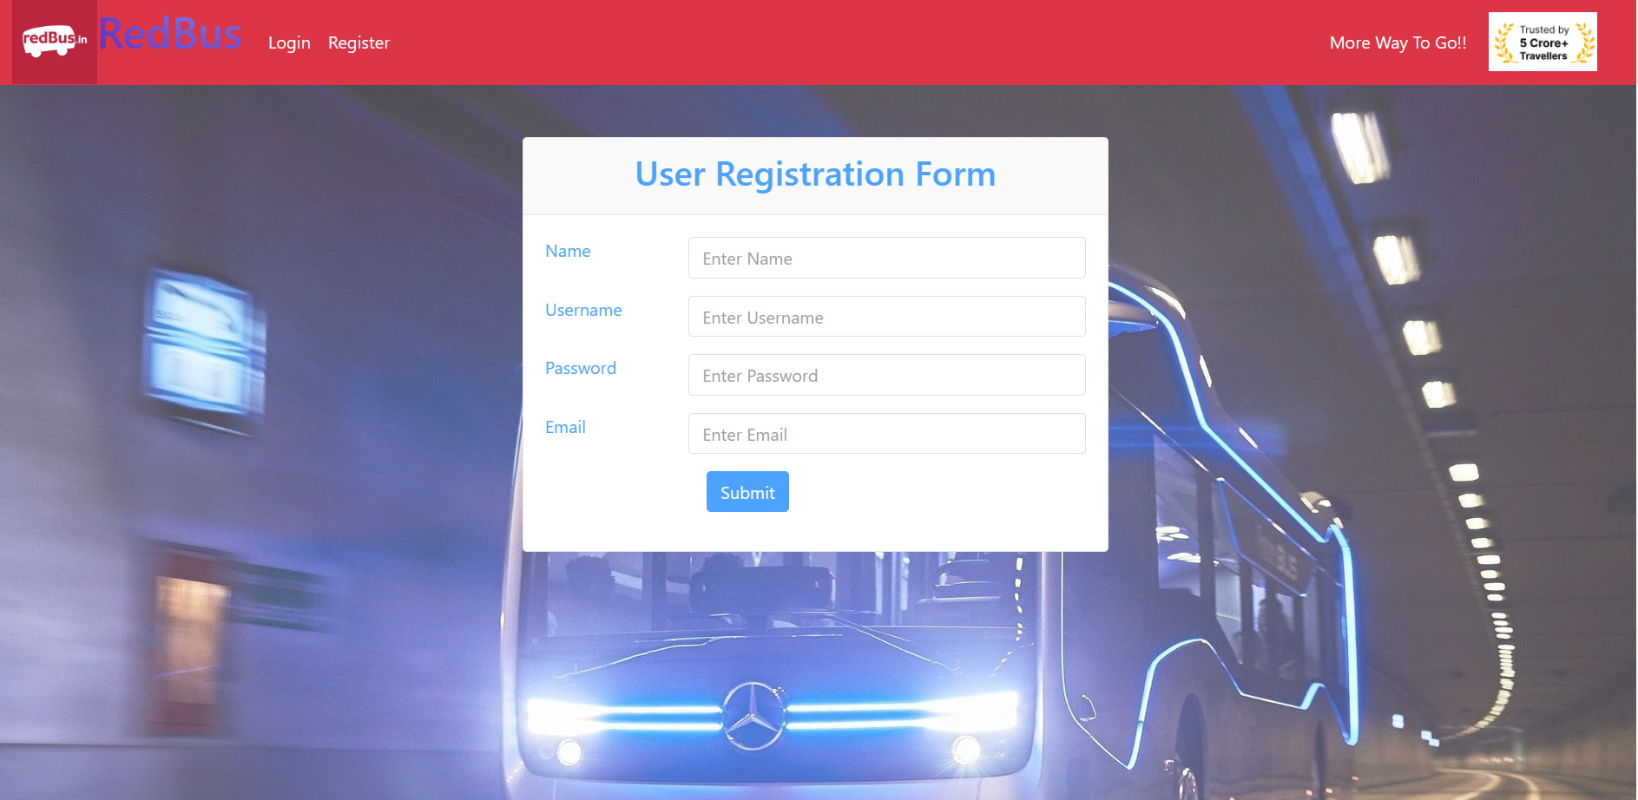

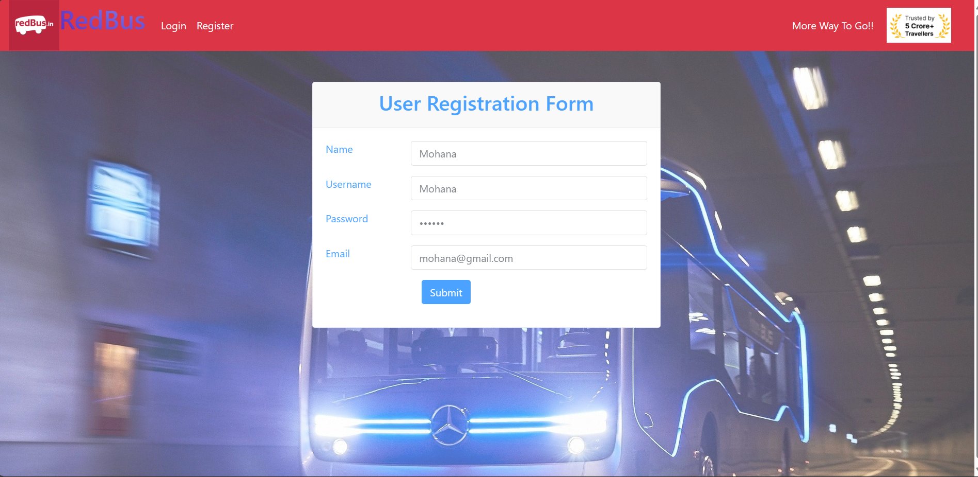

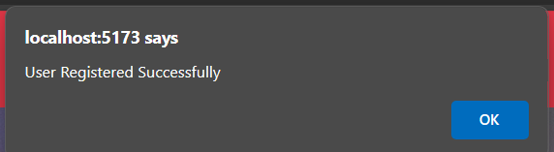

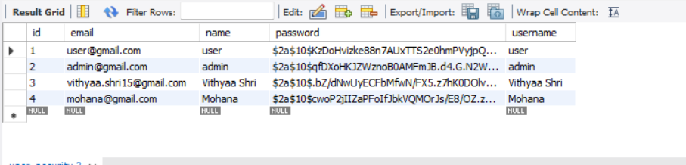

Login as User:

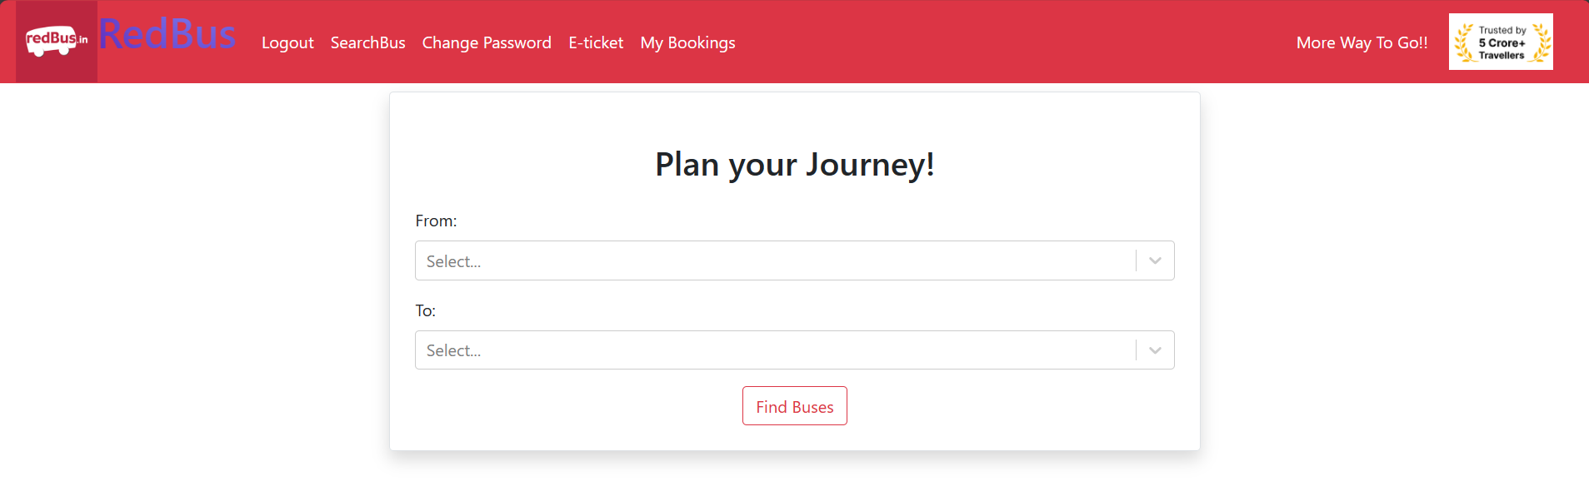

If buses are searched for In Valid route it display Error

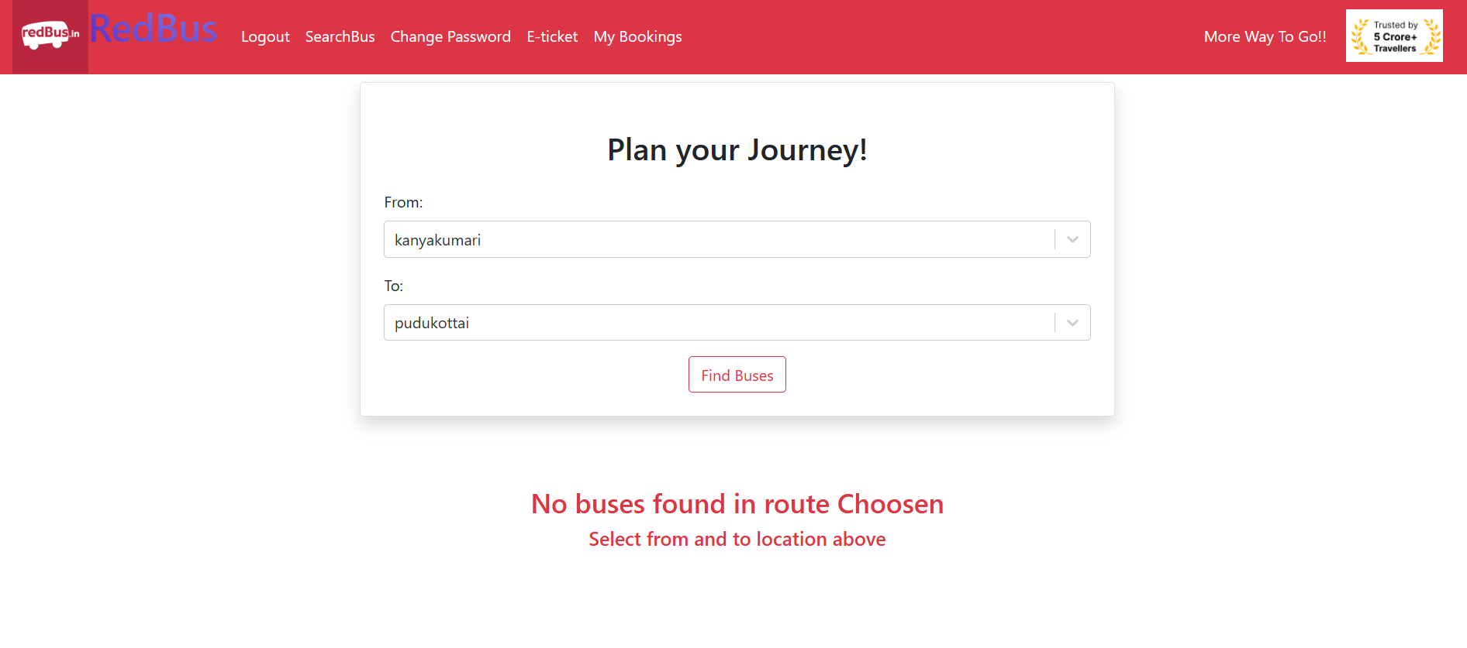

For Valid Route Display the Route:

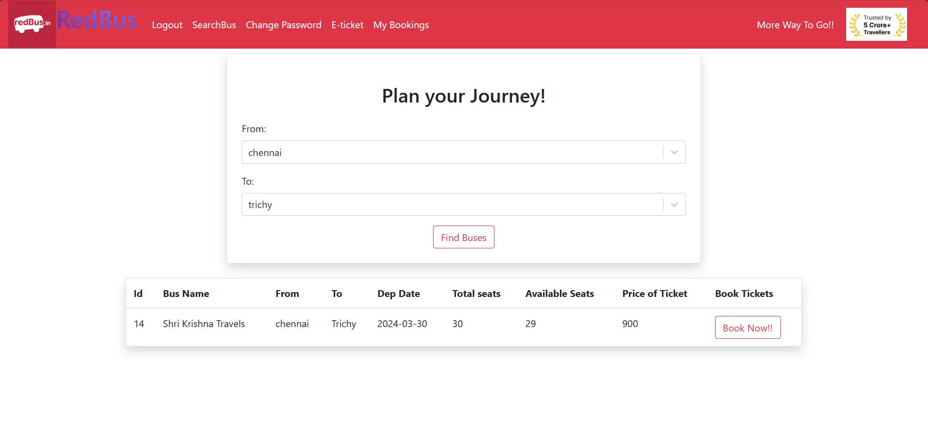

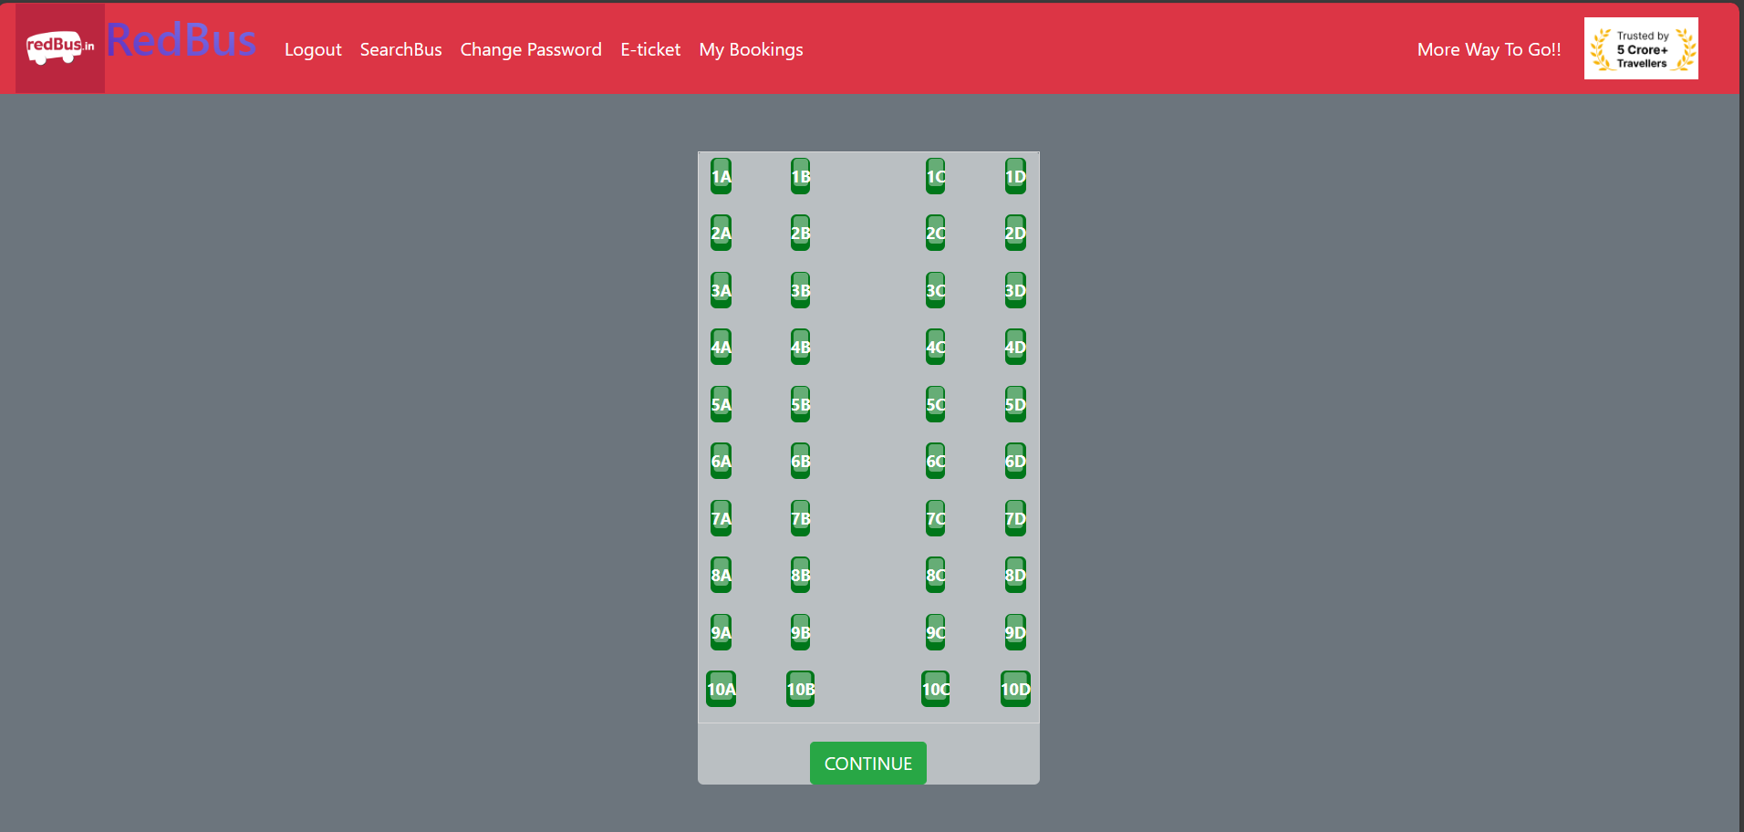

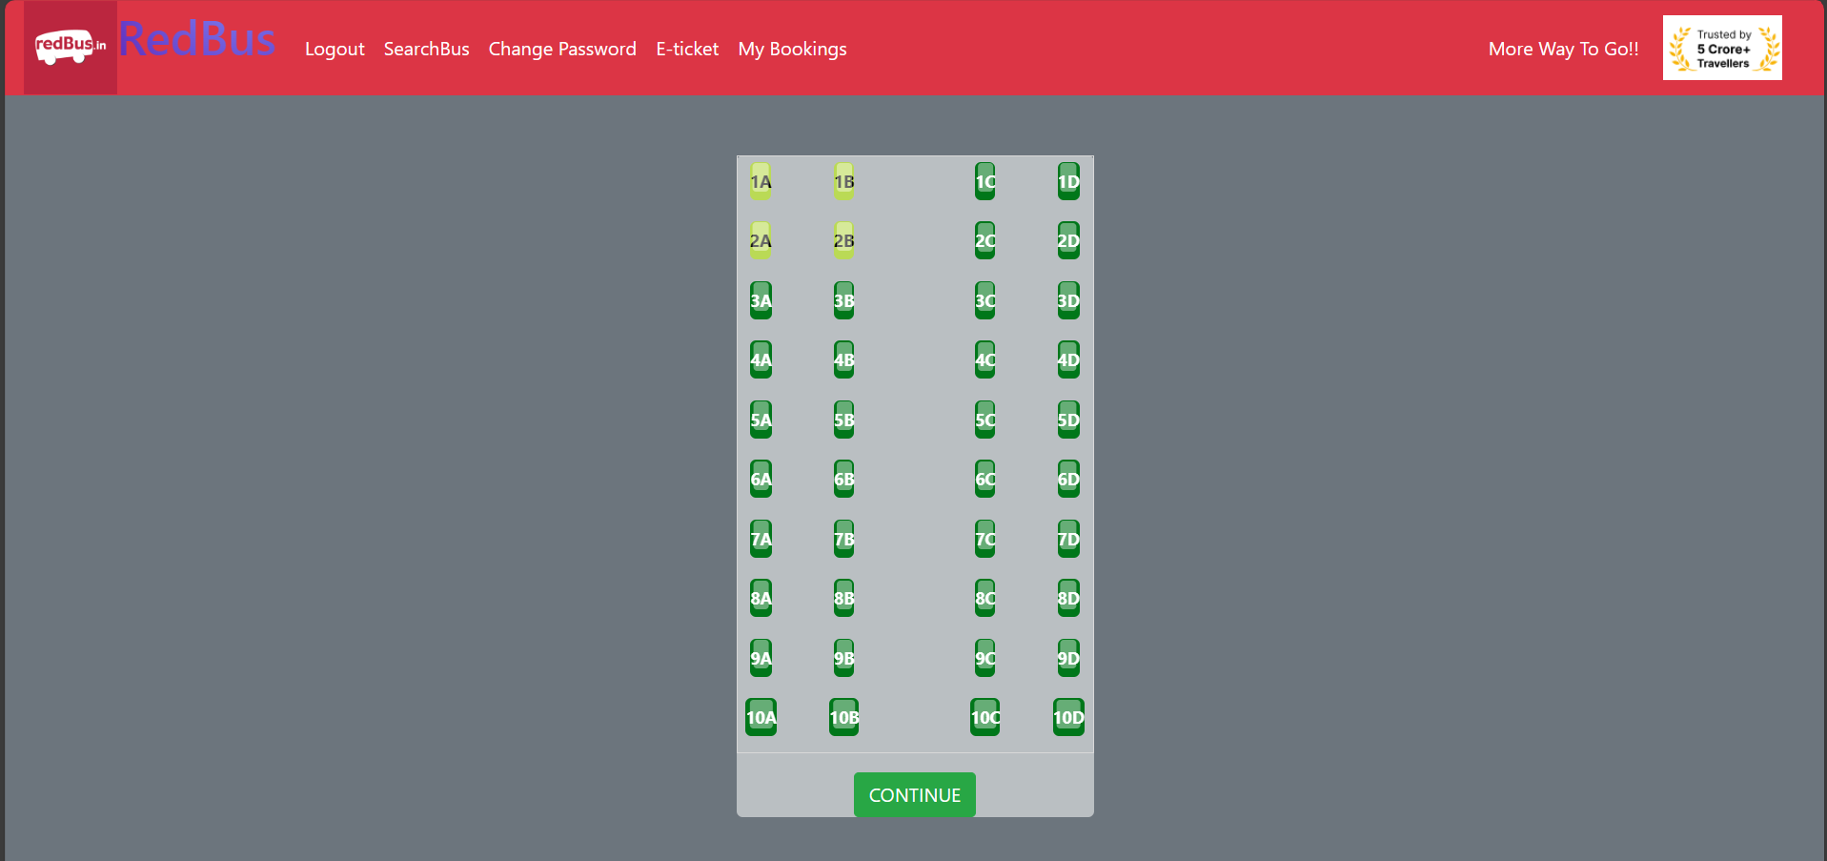

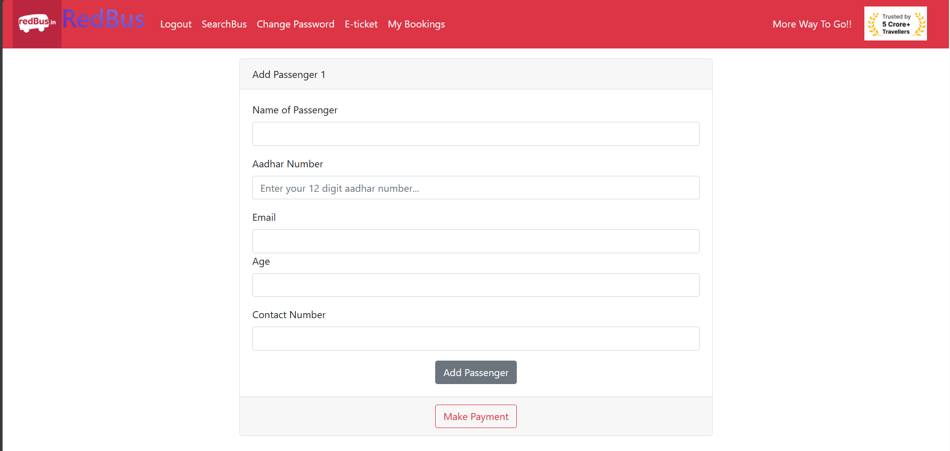

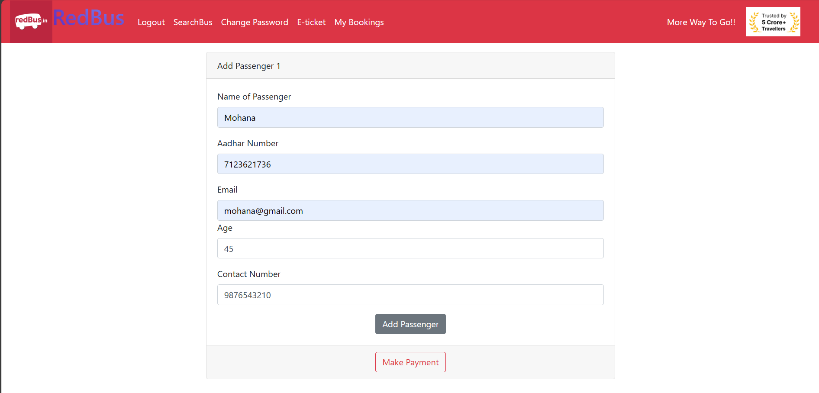

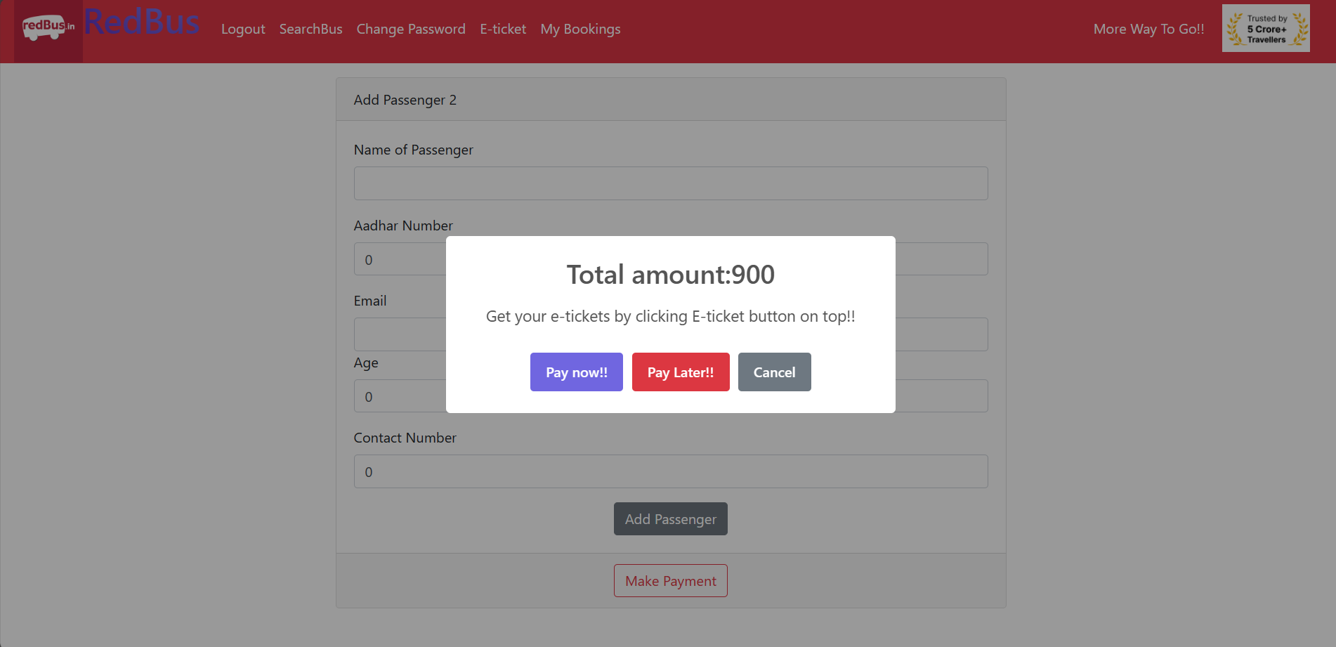

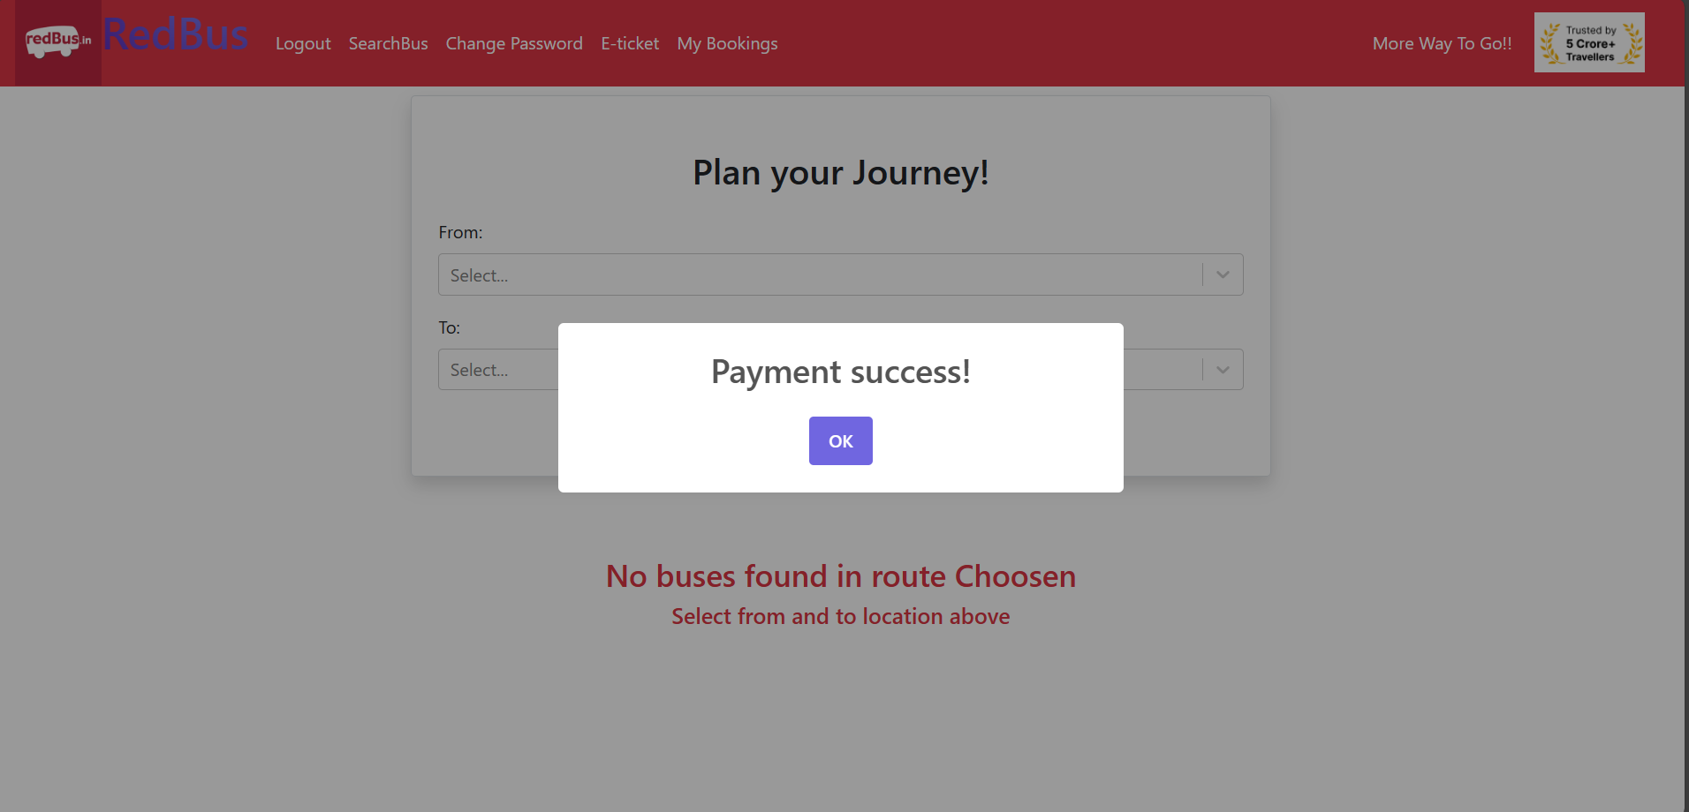

E-Ticket Generation:

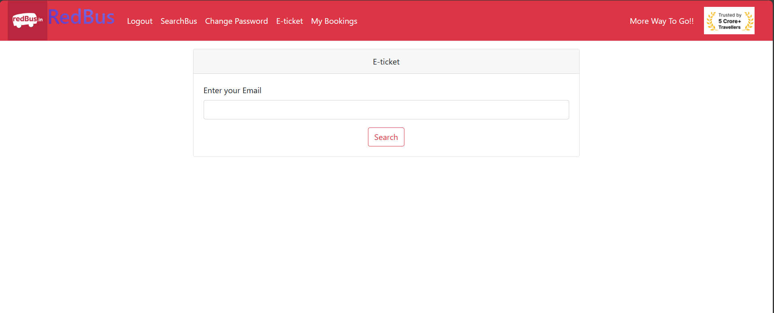

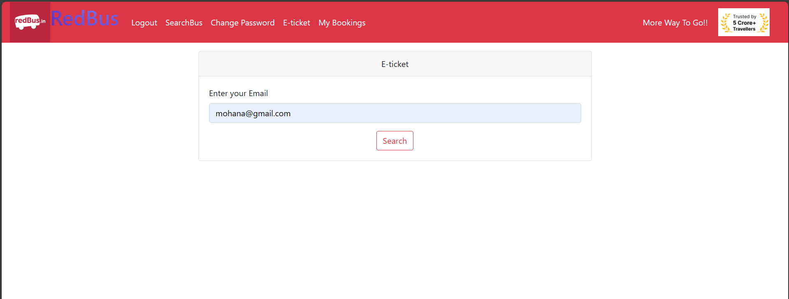

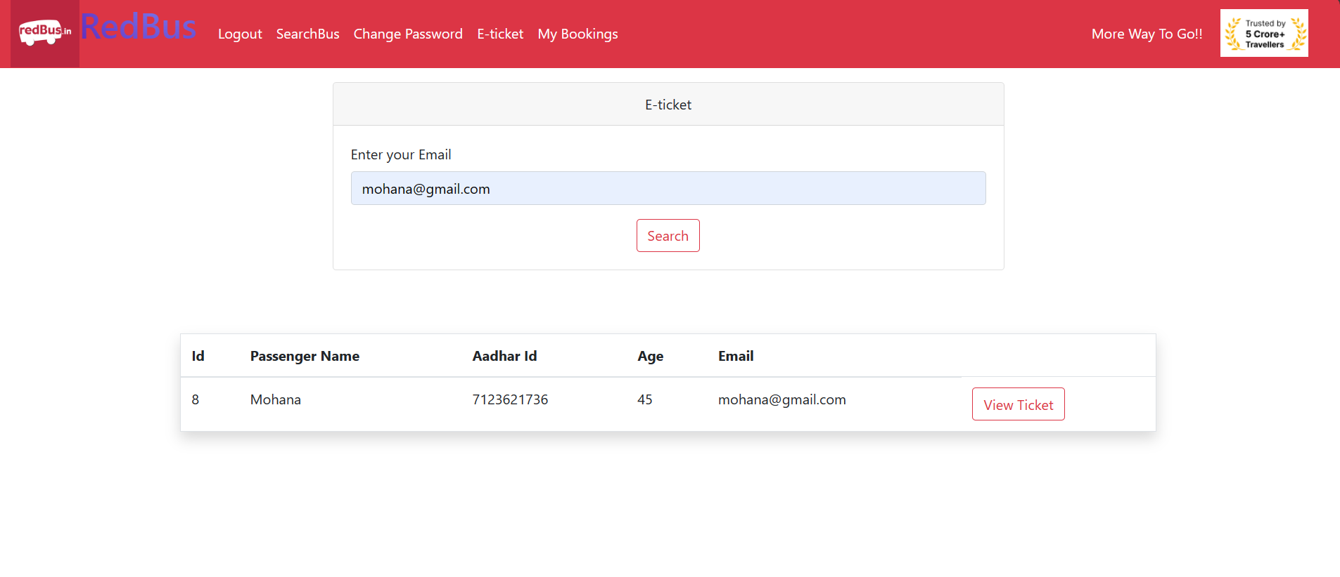

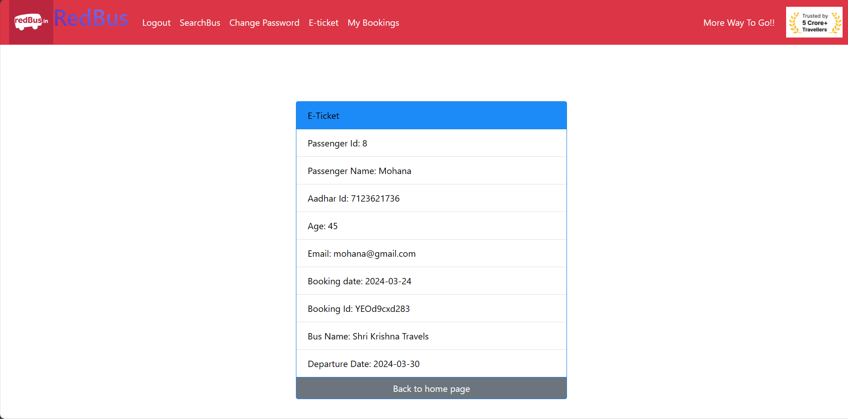

MyBooking:

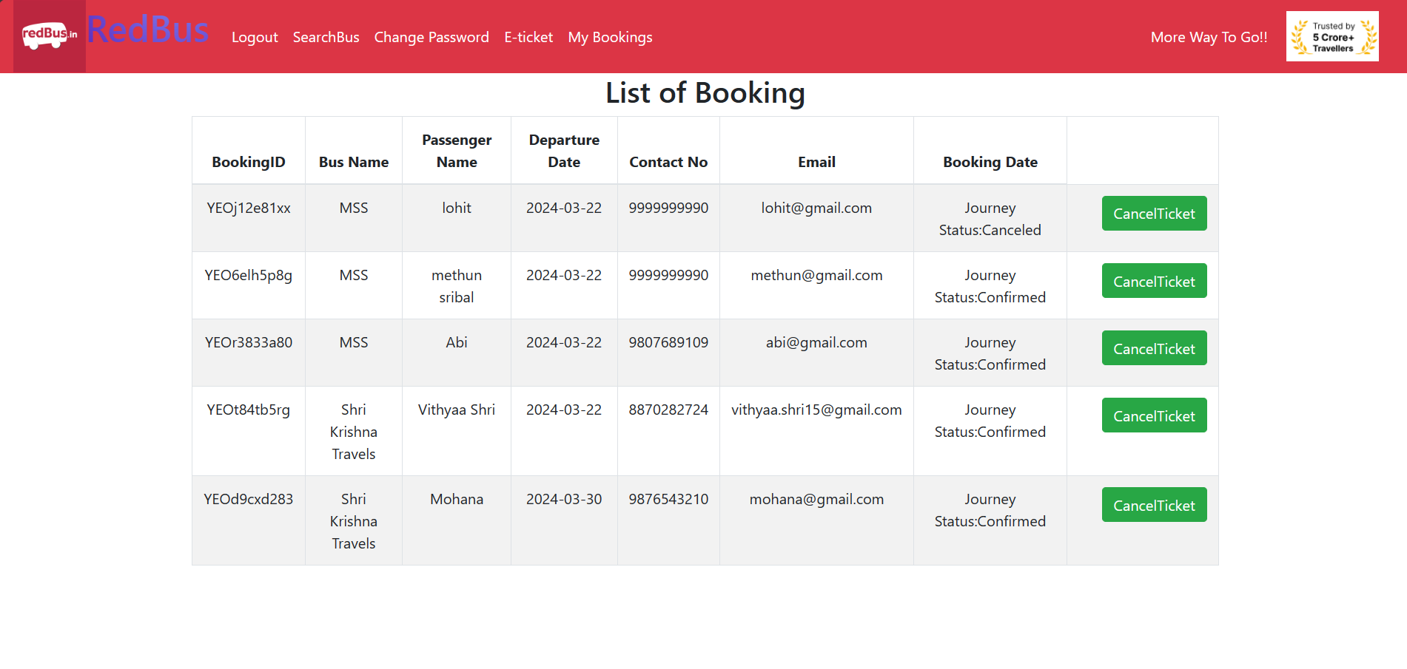

Booking Cnaceled for 2nd Booking Id:

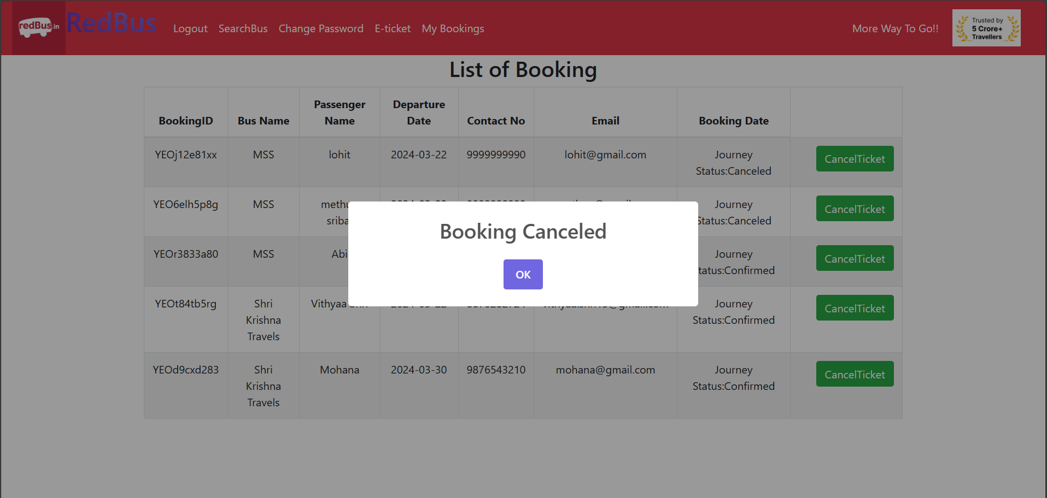



Change Password:

